NexmoCare App



“An app to send SMS on various stages of a ticket’s journey on Zendesk”

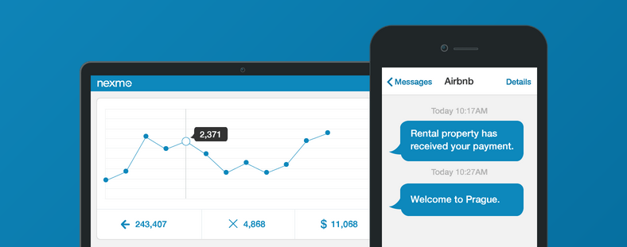

Contents

Introduction 3

Use case 3

Prerequisites 3

Features 3

Steps to install the NexmoCare app 3

Steps to use the NexmoCare app 6

Appendix 10

Nexmo API Keys 10

# Introduction

NexmoCare app will allow Zendesk users to send SMS to the requester on various stages/events of their ticket on Zendesk. Using this app, Zendesk’s users can configure the event as well as SMS text.

# Use case

1. Send SMS on new ticket creation to requester.
2. Send SMS on updating a ticket to requester.
3. Various such events where ticket requester can be informed for change or update in the ticket status.

# Prerequisites

* Zendesk subscription.
* Zendesk admin credentials
* This app requires Nexmo subscription and corresponding Nexmo API keys (Keys and Secret). To access the API keys, see appendix section.
* To configure this app you need internet connectivity.

# Features

* **Custom messaging text:** Allows user to customize the SMS text as per need.
* **Custom placeholder or fields**: While drafting the custom message user can insert custom placeholders or fields.
* **Enable and disable** SMS functionality

# Steps to install the NexmoCare app

1. Login into the Zendesk portal with admin credentials.
2. On dashboard, click on the gear icon in bottom left and select **Manage** under the “APPS” heading.

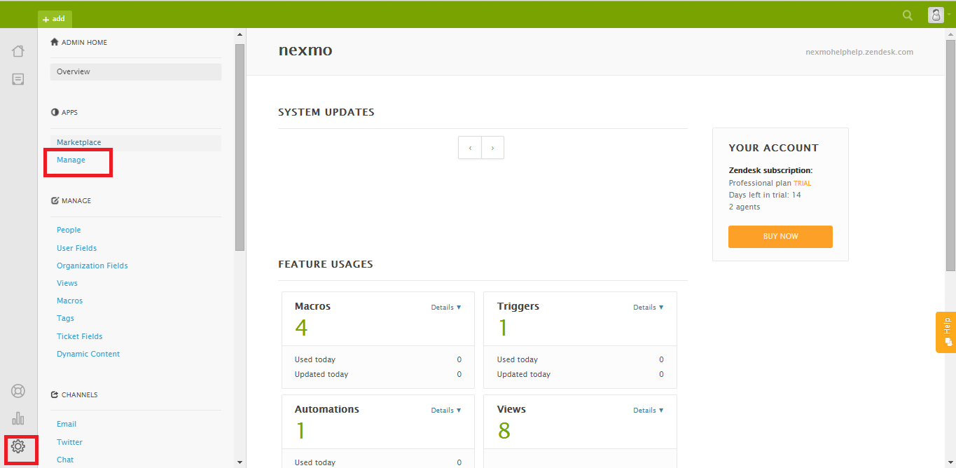

1. Click on **Upload App**.

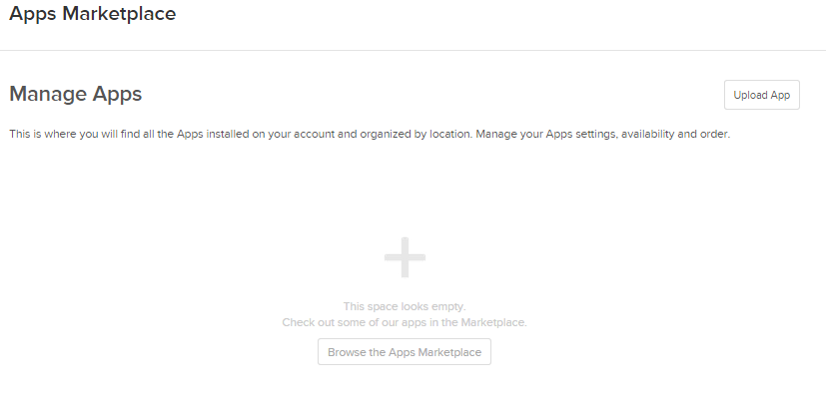

1. Give this installation a name and choose the zip file and click on **Upload**.

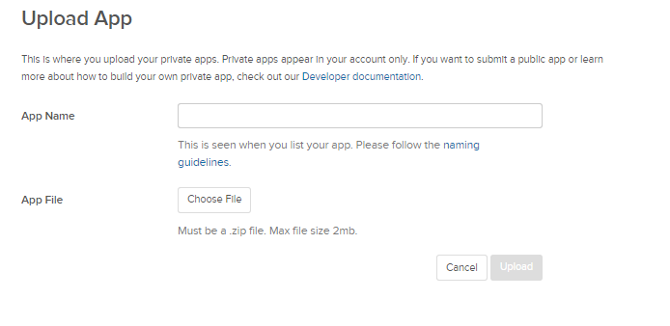

1. A pop up will appear with **T&C**, click on upload.
2. Provide Nexmo API Key, Secret, From Number and click on **Install**.

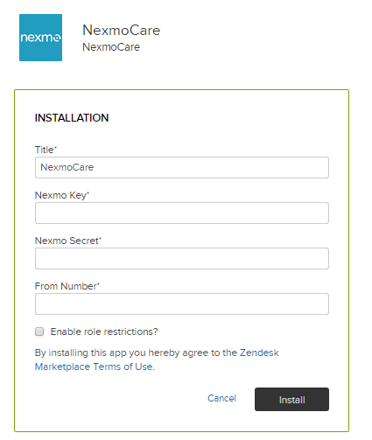

1. App will get installed and listed under **Manage Apps section.**

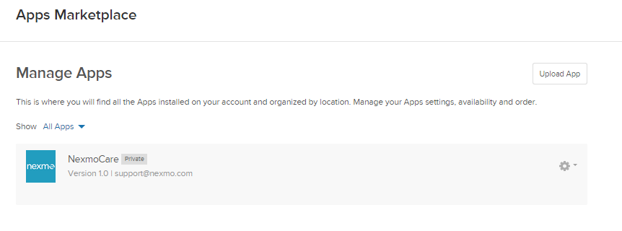

# Steps to use the NexmoCare app

1. Login into the Zendesk portal with admin credentials.
2. Click on **Triggers** in side menu under **BUSINESS RULES** heading.

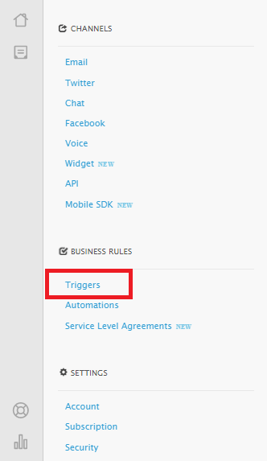

1. Click on **add trigger**

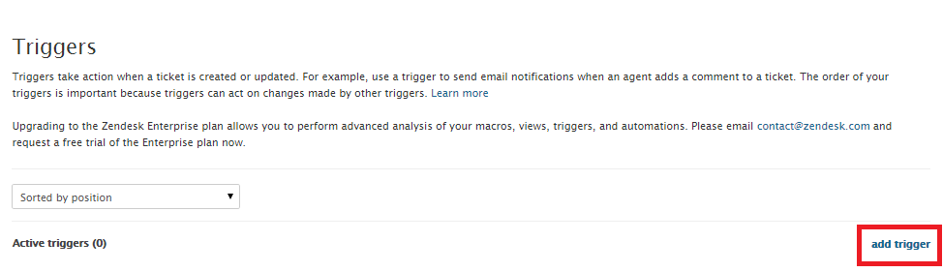

1. You can create a trigger for any event that is mentioned here. For example let us create a trigger when a ticket is created.

Select “Ticket: is” from the drop down.

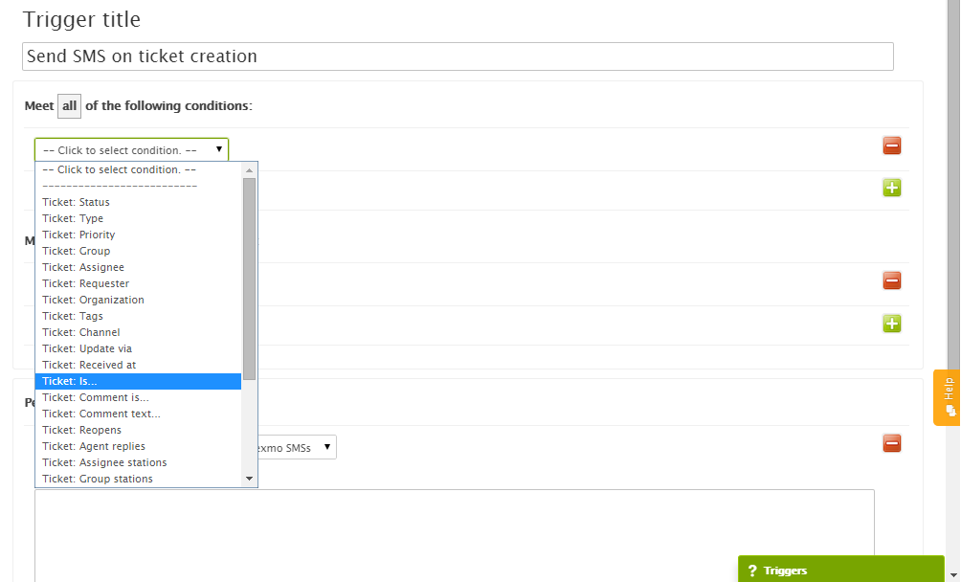

1. Select **Created** from the second drop down as shown in the image below:

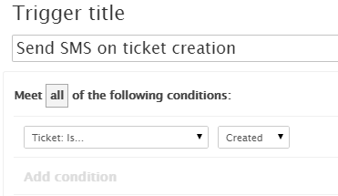

1. Now in **Perform these actions** section**,** choose **Notifications: Notify target** from first drop down and **Nexmo SMSs** from the second drop down as shown in the image below:

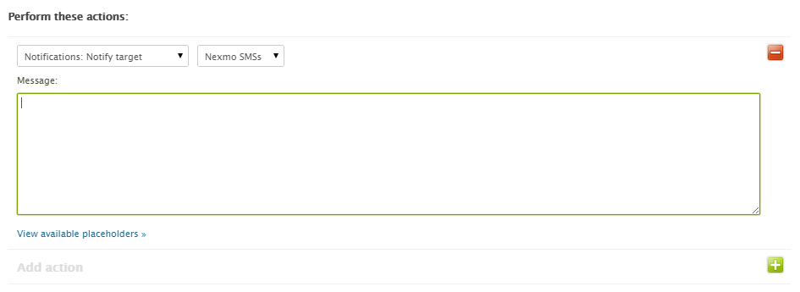

1. Type the message you want to send. Use placeholder wherever you need.

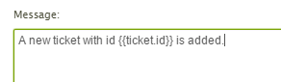

1. If you want to see all the available **placeholders**, click on **View available placeholders** button.

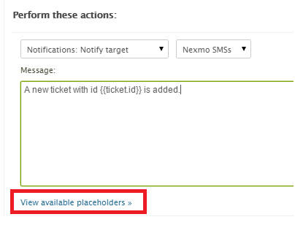

1. When you are done, click on **Create Trigger** from bottom right. Your trigger is created and will be shown in active triggers list.

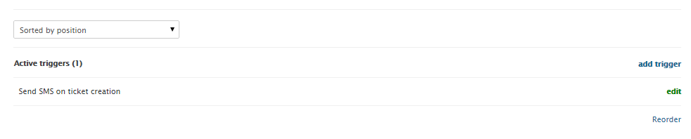

1. Now when you create a new ticket the SMS will be fired on requestor phone number.
2. You can create ticket by clicking **Add** from the top menu and then on ticket and provide relevant details. Make sure the requester has saved their phone number in profile.

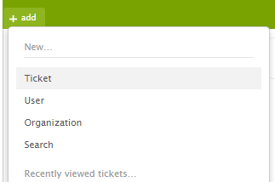

# Appendix

## Nexmo API Keys

* To access the Nexmo keys, go to <https://www.nexmo.com/> and Sign-in.
* On the top right corner, click on the “**Api Settings**”.
* Key and Secret will display in the top bar as shown in the below image:

